**绘制代码**

<!DOCTYPE html>

<html>

<head>

</head>

<body>

<svg xmlns="http://www.w3.org/2000/svg" xmlns:xlink="http://www.w3.org/1999/xlink" width="200" height="200" viewBox="0 0 200 200" fill="none"><g opacity="1" transform="translate(0 0) rotate(0 100 100)"><g opacity="1" transform="translate(78 21) rotate(0 22.5 75.125)"><path id="分组 1" fill-rule="evenodd" style="fill:#231815" transform="translate(0 0) rotate(0 22.5 75.125)" opacity="1" d="M26.2422 11.2546L26.2422 3.7546L18.7422 3.7546L18.7422 11.2546L26.2422 11.2546Z M26 41L26 15L19 15L19 41L26 41Z M4 146.25L41 146.25L41 103.25L41 56.25C41 54.19 39.72 51.1 37.5 48.75C35.27 46.38 31.58 44.75 29.5 44.75L16 44.75C13.94 44.75 9.48 46.4 7 48.75C4.51 51.11 4 54.17 4 56.25L4 146.25Z M22 0L19 0C16.93 0 15.5 1.18 15.5 3.25L15.5 41.25C7.93 41.25 0 47.98 0 56.25L0 150.25L45 150.25L45 56.25C45 47.97 36.87 41.25 29.5 41.25L29.5 3.25C29.5 1.18 28.5 0 26.5 0 "/></g></g>

/Red/<rect xmlns="http://www.w3.org/2000/svg" x="82" y= "0" width="37"

height="0" style="fill:#de1c31;stroke-width:0.1;stroke:rgb(0,0,0)"/>

/Sparkling/<rect xmlns="http://www.w3.org/2000/svg" x="82" y= "0" width="37"

height="0" style="fill:#83cbac;stroke-width:0.1;stroke:rgb(0,0,0)"/>

/Rose/<rect xmlns="http://www.w3.org/2000/svg" x="82" y="0" width="37"

height="0" style="fill:#f17666;stroke-width:0.1;stroke:rgb(0,0,0)"/>

/Fortified/<rect xmlns="http://www.w3.org/2000/svg" x="82" y="0" width="37"

height="0" style="fill:#2e317c;stroke-width:0.1;stroke:rgb(0,0,0)"/>

/Hard/<rect xmlns="http://www.w3.org/2000/svg" x="82" y= "0" width="37"

height="0" style="fill:#bce936;stroke-width:0.1;stroke:rgb(0,0,0)"/>

/White/<rect xmlns="http://www.w3.org/2000/svg" x="82" y="82.5" width="37"

height="0" style="fill:#fbf2e3;stroke-width:0.1;stroke:rgb(0,0,0)"/>

/Etc/<rect xmlns="http://www.w3.org/2000/svg" x="82" y="0" width="37"

height="0" style="fill:#2177b8;stroke-width:0.1;stroke:rgb(0,0,0)"/>

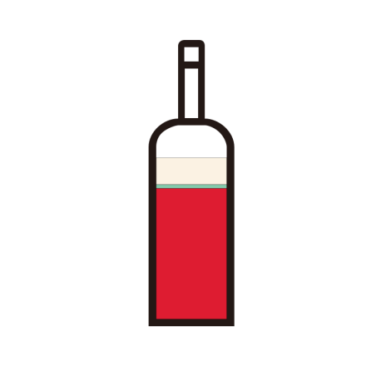

</svg>

</body>

</html>

**Argentina**

/Red/<rect xmlns="http://www.w3.org/2000/svg" x="82" y= "98.82" width="37"

height="68.68" style="fill:#de1c31;stroke-width:0.1;stroke:rgb(0,0,0)"/>

/Sparkling/<rect xmlns="http://www.w3.org/2000/svg" x="82" y= "96.82" width="37"

 height="2" style="fill:#83cbac;stroke-width:0.1;stroke:rgb(0,0,0)"/>

/White/<rect xmlns="http://www.w3.org/2000/svg" x="82" y="82.82" width="37"

height="14" style="fill:#fbf2e3;stroke-width:0.1;stroke:rgb(0,0,0)"/>

**Australia**

**Austria**

/Red/<rect xmlns="http://www.w3.org/2000/svg" x="82" y= "134.7" width="37"

height="32.8" style="fill:#de1c31;stroke-width:0.1;stroke:rgb(0,0,0)"/>

/Sparkling/<rect xmlns="http://www.w3.org/2000/svg" x="82" y= "130.8" width="37"

height="3.9" style="fill:#83cbac;stroke-width:0.1;stroke:rgb(0,0,0)"/>

/Rose/<rect xmlns="http://www.w3.org/2000/svg" x="82" y="126.9" width="37"

height="3.9" style="fill:#f17666;stroke-width:0.1;stroke:rgb(0,0,0)"/>

/White/<rect xmlns="http://www.w3.org/2000/svg" x="82" y="82.5" width="37"

height="44.4" style="fill:#fbf2e3;stroke-width:0.1;stroke:rgb(0,0,0)"/>

**Bulgaria**

/Red/<rect xmlns="http://www.w3.org/2000/svg" x="82" y= "110.8" width="37"

height="56.7" style="fill:#de1c31;stroke-width:0.1;stroke:rgb(0,0,0)"/>

/White/<rect xmlns="http://www.w3.org/2000/svg" x="82" y="82.5" width="37"

height="28.5" style="fill:#fbf2e3;stroke-width:0.1;stroke:rgb(0,0,0)"/>

**Canada**

/Red/<rect xmlns="http://www.w3.org/2000/svg" x="82" y= "155.4" width="37"

height="12.1" style="fill:#de1c31;stroke-width:0.1;stroke:rgb(0,0,0)"/>

/Sparkling/<rect xmlns="http://www.w3.org/2000/svg" x="82" y= "151.3" width="37"

height="4.1" style="fill:#83cbac;stroke-width:0.1;stroke:rgb(0,0,0)"/>

/White/<rect xmlns="http://www.w3.org/2000/svg" x="82" y="82.5" width="37"

height="68.8" style="fill:#fbf2e3;stroke-width:0.1;stroke:rgb(0,0,0)"/>

**Chile**

/Red/<rect xmlns="http://www.w3.org/2000/svg" x="82" y= "102" width="37"

height="65.5" style="fill:#de1c31;stroke-width:0.1;stroke:rgb(0,0,0)"/>

/Sparkling/<rect xmlns="http://www.w3.org/2000/svg" x="82" y= "101" width="37"

height="1" style="fill:#83cbac;stroke-width:0.1;stroke:rgb(0,0,0)"/>

****/Rose/<rect xmlns="http://www.w3.org/2000/svg" x="82" y="100.5" width="37"

height="0.5" style="fill:#f17666;stroke-width:0.1;stroke:rgb(0,0,0)"/>

/White/<rect xmlns="http://www.w3.org/2000/svg" x="82" y="82.5" width="37"

height="18" style="fill:#fbf2e3;stroke-width:0.1;stroke:rgb(0,0,0)"/>

**Croatia**

同Bulgaria



**France**

/Red/<rect xmlns="http://www.w3.org/2000/svg" x="82" y= "115.1" width="37"

height="52.4" style="fill:#de1c31;stroke-width:0.1;stroke:rgb(0,0,0)"/>

/Sparkling/<rect xmlns="http://www.w3.org/2000/svg" x="82" y= "103.5" width="37"

height="11.6" style="fill:#83cbac;stroke-width:0.1;stroke:rgb(0,0,0)"/>

/Rose/<rect xmlns="http://www.w3.org/2000/svg" x="82" y="102.2" width="37"

height="1.3" style="fill:#f17666;stroke-width:0.1;stroke:rgb(0,0,0)"/>

/Hard/<rect xmlns="http://www.w3.org/2000/svg" x="82" y= "101.6" width="37"

height="0.6" style="fill:#bce936;stroke-width:0.1;stroke:rgb(0,0,0)"/>

/White/<rect xmlns="http://www.w3.org/2000/svg" x="82" y="82.5" width="37"

height="18.9" style="fill:#fbf2e3;stroke-width:0.1;stroke:rgb(0,0,0)"/>

**Georgia**

/Red/<rect xmlns="http://www.w3.org/2000/svg" x="82" y= "128.3" width="37"

height="39.2" style="fill:#de1c31;stroke-width:0.1;stroke:rgb(0,0,0)"/>

/White/<rect xmlns="http://www.w3.org/2000/svg" x="82" y="82.5" width="37"

height="45.8" style="fill:#fbf2e3;stroke-width:0.1;stroke:rgb(0,0,0)"/>

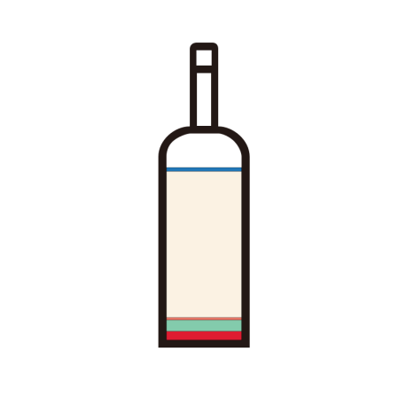**Germany**

/Red/<rect xmlns="http://www.w3.org/2000/svg" x="82" y= "163.2" width="37"

height="4.3" style="fill:#de1c31;stroke-width:0.1;stroke:rgb(0,0,0)"/>

/Sparkling/<rect xmlns="http://www.w3.org/2000/svg" x="82" y= "157.6" width="37"

height="5.6" style="fill:#83cbac;stroke-width:0.1;stroke:rgb(0,0,0)"/>

/Rose/<rect xmlns="http://www.w3.org/2000/svg" x="82" y="156.4" width="37"

height="1.2" style="fill:#f17666;stroke-width:0.1;stroke:rgb(0,0,0)"/>

/White/<rect xmlns="http://www.w3.org/2000/svg" x="82" y="84.4" width="37"

height="72" style="fill:#fbf2e3;stroke-width:0.1;stroke:rgb(0,0,0)"/>

/Etc/<rect xmlns="http://www.w3.org/2000/svg" x="82" y="82.5" width="37"

height="1.9" style="fill:#2177b8;stroke-width:0.1;stroke:rgb(0,0,0)"/>

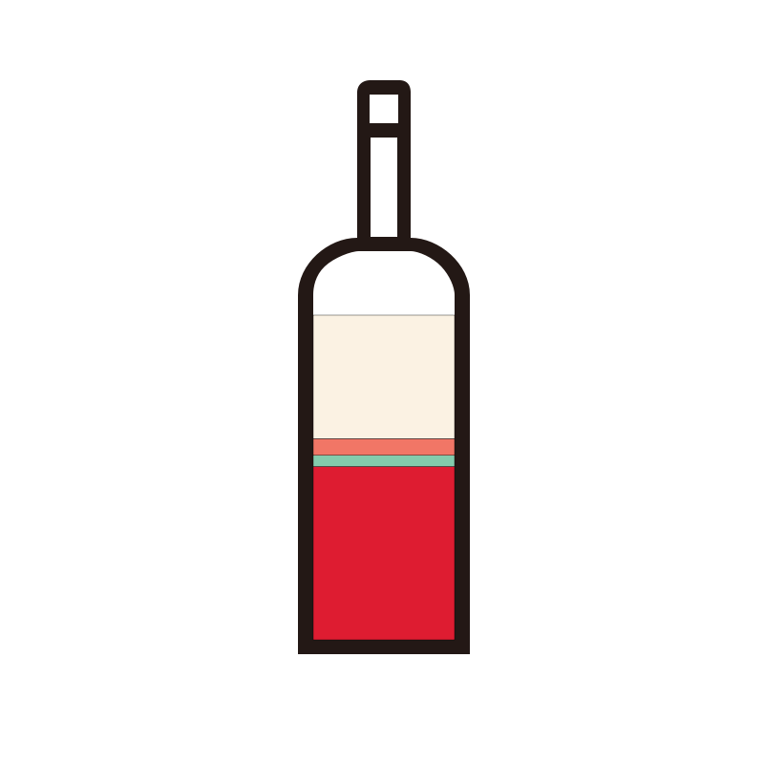

**Greece**

/Red/<rect xmlns="http://www.w3.org/2000/svg" x="82" y= "122.1" width="37"

height="45.4" style="fill:#de1c31;stroke-width:0.1;stroke:rgb(0,0,0)"/>

/Sparkling/<rect xmlns="http://www.w3.org/2000/svg" x="82" y= "119.2" width="37"

height="2.9" style="fill:#83cbac;stroke-width:0.1;stroke:rgb(0,0,0)"/>

/Rose/<rect xmlns="http://www.w3.org/2000/svg" x="82" y="114.8" width="37"

height="4.4" style="fill:#f17666;stroke-width:0.1;stroke:rgb(0,0,0)"/>

/White/<rect xmlns="http://www.w3.org/2000/svg" x="82" y="82.5" width="37"

height="32.3" style="fill:#fbf2e3;stroke-width:0.1;stroke:rgb(0,0,0)"/>

**Hungary**

/Red/<rect xmlns="http://www.w3.org/2000/svg" x="82" y= "143.2" width="37"

height="24.3" style="fill:#de1c31;stroke-width:0.1;stroke:rgb(0,0,0)"/>

/White/<rect xmlns="http://www.w3.org/2000/svg" x="82" y="82.5" width="37"

height="60.7" style="fill:#fbf2e3;stroke-width:0.1;stroke:rgb(0,0,0)"/>

**Israel**

全红

**Italy**

/Red/<rect xmlns="http://www.w3.org/2000/svg" x="82" y= "112.6" width="37"

 height="54.6" style="fill:#de1c31;stroke-width:0.1;stroke:rgb(0,0,0)"/>

/Sparkling/<rect xmlns="http://www.w3.org/2000/svg" x="82" y= "103.7" width="37"

height="9.2" style="fill:#83cbac;stroke-width:0.1;stroke:rgb(0,0,0)"/>

/Rose/<rect xmlns="http://www.w3.org/2000/svg" x="82" y="102.4" width="37"

height="1.3" style="fill:#f17666;stroke-width:0.1;stroke:rgb(0,0,0)"/>

/Fortified/<rect xmlns="http://www.w3.org/2000/svg" x="82" y="0" width="37"

height="0" style="fill:#2e317c;stroke-width:0.1;stroke:rgb(0,0,0)"/>

/Hard/<rect xmlns="http://www.w3.org/2000/svg" x="82" y= "101.1" width="37"

height="1.1" style="fill:#bce936;stroke-width:0.1;stroke:rgb(0,0,0)"/>

/White/<rect xmlns="http://www.w3.org/2000/svg" x="82" y="82.5" width="37"

height="18.6" style="fill:#fbf2e3;stroke-width:0.1;stroke:rgb(0,0,0)"/>

**Japan**

/Red/<rect xmlns="http://www.w3.org/2000/svg" x="82" y= "139.2" width="37"

height="28.3" style="fill:#de1c31;stroke-width:0.1;stroke:rgb(0,0,0)"/>

/White/<rect xmlns="http://www.w3.org/2000/svg" x="82" y="82.5" width="37"

height="56.7" style="fill:#fbf2e3;stroke-width:0.1;stroke:rgb(0,0,0)"/>

**Korea**

/Red/<rect xmlns="http://www.w3.org/2000/svg" x="82" y= "150.5" width="37"

height="17" style="fill:#de1c31;stroke-width:0.1;stroke:rgb(0,0,0)"/>

/Sparkling/<rect xmlns="http://www.w3.org/2000/svg" x="82" y= "125" width="37"

height="25.5" style="fill:#83cbac;stroke-width:0.1;stroke:rgb(0,0,0)"/>

/Fortified/<rect xmlns="http://www.w3.org/2000/svg" x="82" y="108" width="37"

height="17" style="fill:#2e317c;stroke-width:0.1;stroke:rgb(0,0,0)"/>

/White/<rect xmlns="http://www.w3.org/2000/svg" x="82" y="82.5" width="37"

 height="25.5" style="fill:#fbf2e3;stroke-width:0.1;stroke:rgb(0,0,0)"/>

**Moldova**

/Sparkling/<rect xmlns="http://www.w3.org/2000/svg" x="82" y= "124.75" width="37"

height="42.75" style="fill:#83cbac;stroke-width:0.1;stroke:rgb(0,0,0)"/>

/Rose/<rect xmlns="http://www.w3.org/2000/svg" x="82" y="82.5" width="37"

height="42.75" style="fill:#f17666;stroke-width:0.1;stroke:rgb(0,0,0)"/>

**New Zealand**

/Red/<rect xmlns="http://www.w3.org/2000/svg" x="82" y= "137.1" width="37"

height="30.4" style="fill:#de1c31;stroke-width:0.1;stroke:rgb(0,0,0)"/>

/Sparkling/<rect xmlns="http://www.w3.org/2000/svg" x="82" y= "134.9" width="37"

height="2.2" style="fill:#83cbac;stroke-width:0.1;stroke:rgb(0,0,0)"/>

/White/<rect xmlns="http://www.w3.org/2000/svg" x="82" y="82.5" width="37"

height="52.4" style="fill:#fbf2e3;stroke-width:0.1;stroke:rgb(0,0,0)"/>

**Portugal**

/Red/<rect xmlns="http://www.w3.org/2000/svg" x="82" y= "142.7" width="37"

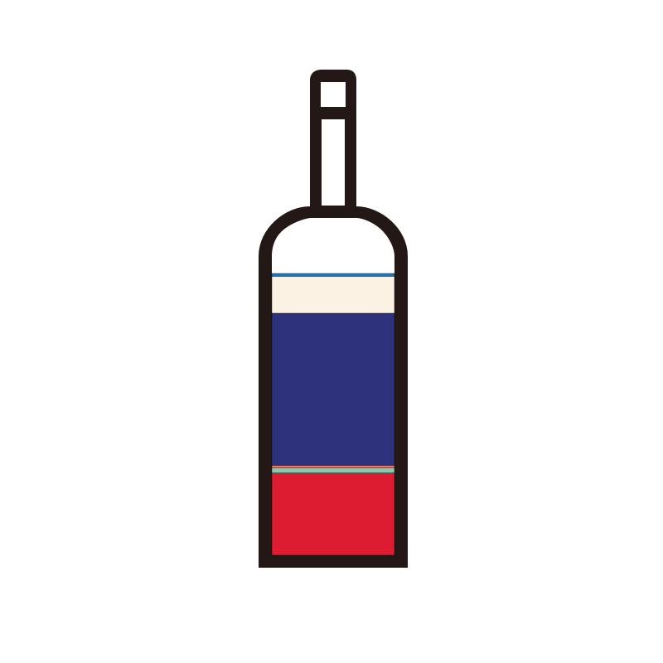 height="24.8" style="fill:#de1c31;stroke-width:0.1;stroke:rgb(0,0,0)"/>

/Sparkling/<rect xmlns="http://www.w3.org/2000/svg" x="82" y= "141.2" width="37"

height="1.5" style="fill:#83cbac;stroke-width:0.1;stroke:rgb(0,0,0)"/>

/Rose/<rect xmlns="http://www.w3.org/2000/svg" x="82" y="140.4" width="37"

height="0.8" style="fill:#f17666;stroke-width:0.1;stroke:rgb(0,0,0)"/>

/Fortified/<rect xmlns="http://www.w3.org/2000/svg" x="82" y="94.5" width="37"

 height="45.9" style="fill:#2e317c;stroke-width:0.1;stroke:rgb(0,0,0)"/>

/White/<rect xmlns="http://www.w3.org/2000/svg" x="82" y="83.2" width="37"

height="11.3" style="fill:#fbf2e3;stroke-width:0.1;stroke:rgb(0,0,0)"/>

/Etc/<rect xmlns="http://www.w3.org/2000/svg" x="82" y="82.5" width="37"

height="0.9" style="fill:#2177b8;stroke-width:0.1;stroke:rgb(0,0,0)"/>

**Romania**

同Bulgaria

**Slovenia**

/Red/<rect xmlns="http://www.w3.org/2000/svg" x="82" y= "145.2" width="37"

height="22.3" style="fill:#de1c31;stroke-width:0.1;stroke:rgb(0,0,0)"/>

/Sparkling/<rect xmlns="http://www.w3.org/2000/svg" x="82" y= "140.7" width="37"

height="4.5" style="fill:#83cbac;stroke-width:0.1;stroke:rgb(0,0,0)"/>

/White/<rect xmlns="http://www.w3.org/2000/svg" x="82" y="82.5" width="37"

height="58.2" style="fill:#fbf2e3;stroke-width:0.1;stroke:rgb(0,0,0)"/>

**Spain**

/Red/<rect xmlns="http://www.w3.org/2000/svg" x="82" y= "112.1" width="37"

 height="55.4" style="fill:#de1c31;stroke-width:0.1;stroke:rgb(0,0,0)"/>

/Sparkling/<rect xmlns="http://www.w3.org/2000/svg" x="82" y= "101.7" width="37"

height="10.4" style="fill:#83cbac;stroke-width:0.1;stroke:rgb(0,0,0)"/>

/Rose/<rect xmlns="http://www.w3.org/2000/svg" x="82" y="99.7" width="37"

height="2" style="fill:#f17666;stroke-width:0.1;stroke:rgb(0,0,0)"/>

/Fortified/<rect xmlns="http://www.w3.org/2000/svg" x="82" y="98.5" width="37"

height="1.2" style="fill:#2e317c;stroke-width:0.1;stroke:rgb(0,0,0)"/>

/White/<rect xmlns="http://www.w3.org/2000/svg" x="82" y="84.5" width="37"

height="14" style="fill:#fbf2e3;stroke-width:0.1;stroke:rgb(0,0,0)"/>

/Etc/<rect xmlns="http://www.w3.org/2000/svg" x="82" y="82.5" width="37"

 height="2" style="fill:#2177b8;stroke-width:0.1;stroke:rgb(0,0,0)"/>

**the Republic of South Africa**

/Red/<rect xmlns="http://www.w3.org/2000/svg" x="82" y= "112.6" width="37"

height="54.9" style="fill:#de1c31;stroke-width:0.1;stroke:rgb(0,0,0)"/>

/Sparkling/<rect xmlns="http://www.w3.org/2000/svg" x="82" y= "108" width="37"

height="4.6" style="fill:#83cbac;stroke-width:0.1;stroke:rgb(0,0,0)"/>

/Rose/<rect xmlns="http://www.w3.org/2000/svg" x="82" y="104.5" width="37"

height="3.3" style="fill:#f17666;stroke-width:0.1;stroke:rgb(0,0,0)"/>

/White/<rect xmlns="http://www.w3.org/2000/svg" x="82" y="82.5" width="37"

height="22.2" style="fill:#fbf2e3;stroke-width:0.1;stroke:rgb(0,0,0)"/>

**UK**

全绿

/Sparkling/<rect xmlns="http://www.w3.org/2000/svg" x="82" y= "82.5" width="37"

 height="85" style="fill:#83cbac;stroke-width:0.1;stroke:rgb(0,0,0)"/>

**Uruguay**

/Red/<rect xmlns="http://www.w3.org/2000/svg" x="82" y= "103.75" width="37"

height="63.75" style="fill:#de1c31;stroke-width:0.1;stroke:rgb(0,0,0)"/>

/Sparkling/<rect xmlns="http://www.w3.org/2000/svg" x="82" y= "82.5" width="37"

height="21.25" style="fill:#83cbac;stroke-width:0.1;stroke:rgb(0,0,0)"/>

**USA**

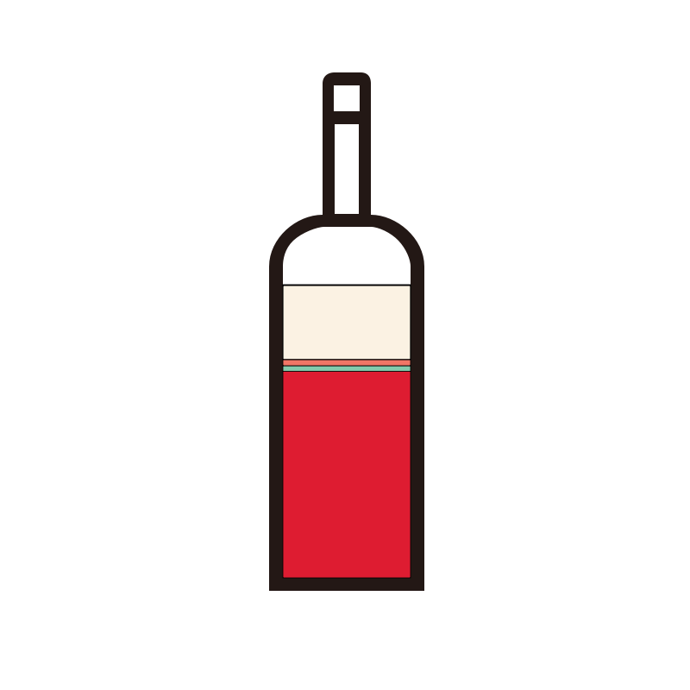/Red/<rect xmlns="http://www.w3.org/2000/svg" x="82" y= "107.6" width="37"

height="59.9" style="fill:#de1c31;stroke-width:0.2;stroke:rgb(0,0,0)"/>

/Sparkling/<rect xmlns="http://www.w3.org/2000/svg" x="82" y= "106" width="37"

height="1.6" style="fill:#83cbac;stroke-width:0.2;stroke:rgb(0,0,0)"/>

/Rose/<rect xmlns="http://www.w3.org/2000/svg" x="82" y="104.2" width="37"

height="1.8" style="fill:#f17666;stroke-width:0.2;stroke:rgb(0,0,0)"/>

/White/<rect xmlns="http://www.w3.org/2000/svg" x="82" y="82.7" width="37"

height="21.5" style="fill:#fbf2e3;stroke-width:0.3;stroke:rgb(0,0,0)"/>

/Etc/<rect xmlns="http://www.w3.org/2000/svg" x="82" y="82.5" width="37"

height="0.2" style="fill:#2177b8;stroke-width:0.2;stroke:rgb(0,0,0)"/>